User Documentation of ResProVis

Step 1: Login to your WordPress Admin Panel

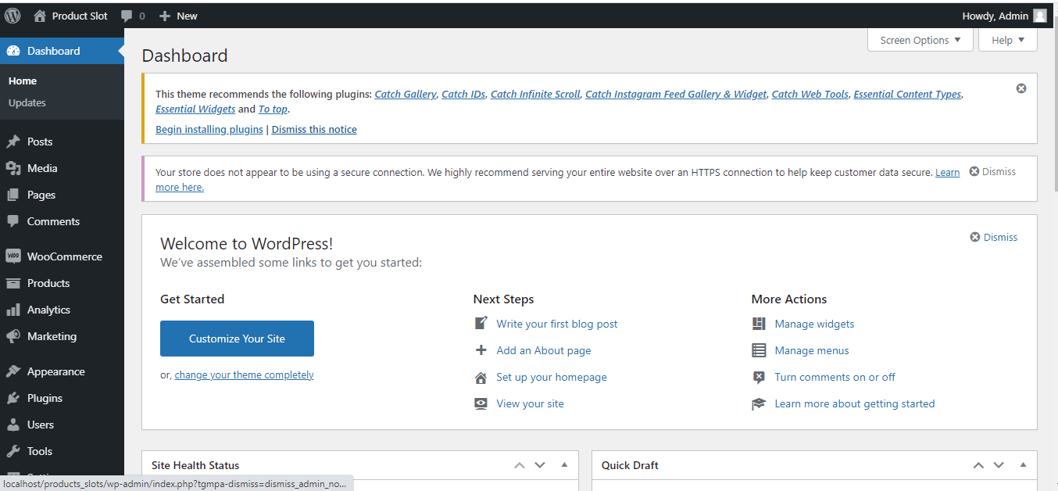

Step 2: Navigate to à Plugins à Add New à Upload Plugin

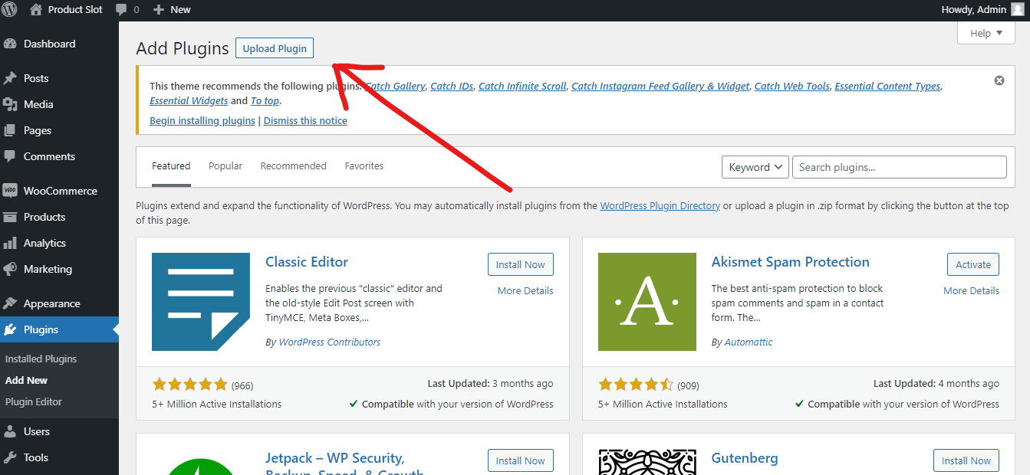

Upload plugin zip file, then click on Install Now

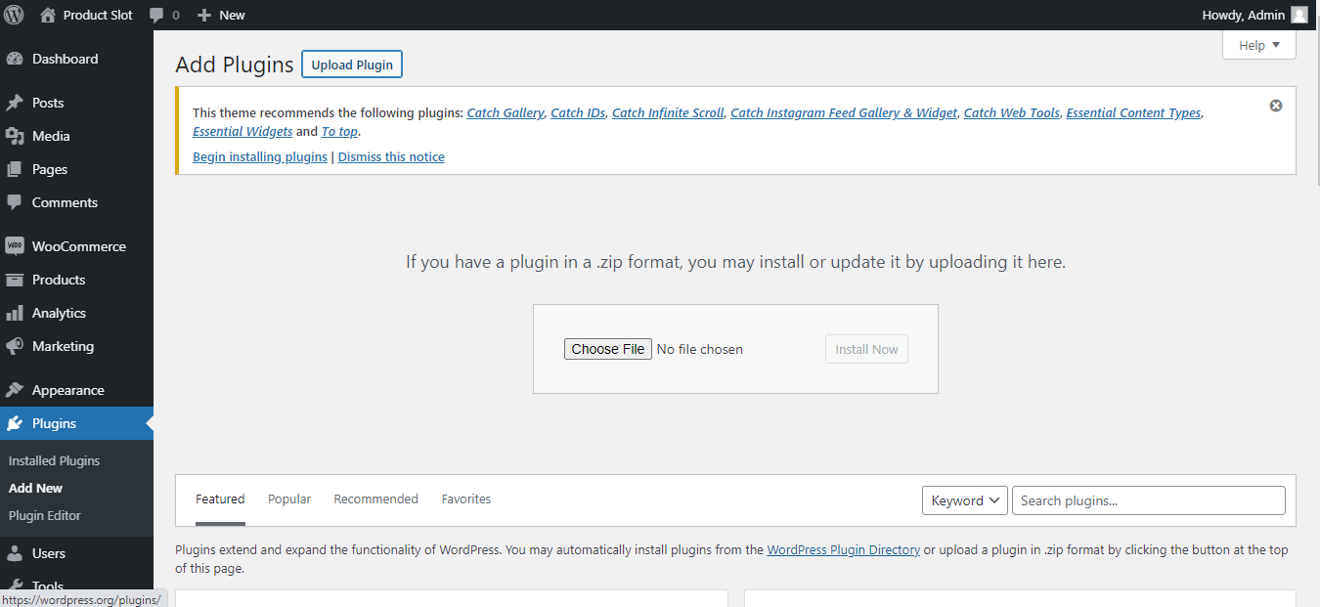

Step 3: Then, Click on Activate Plugin

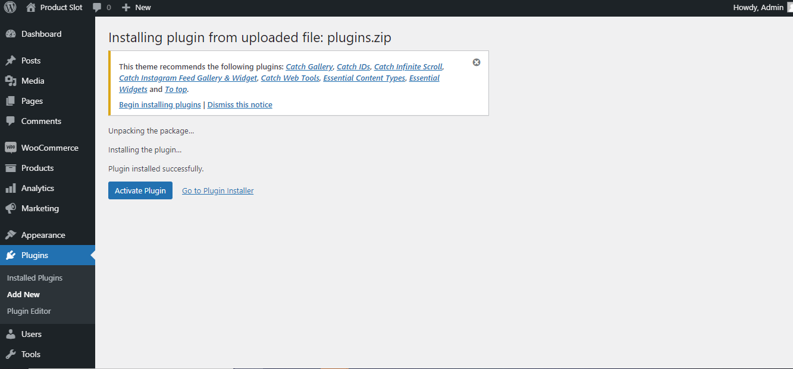

Step 4: After activating the plugin, you will see the plugin (ResProVis ) under the installed plugins list

Step 5: After the successful installation & activation of the ResProVis Plugin, you will automatically see checkboxes(Weekdays Slots) under WooCommerce add new products page

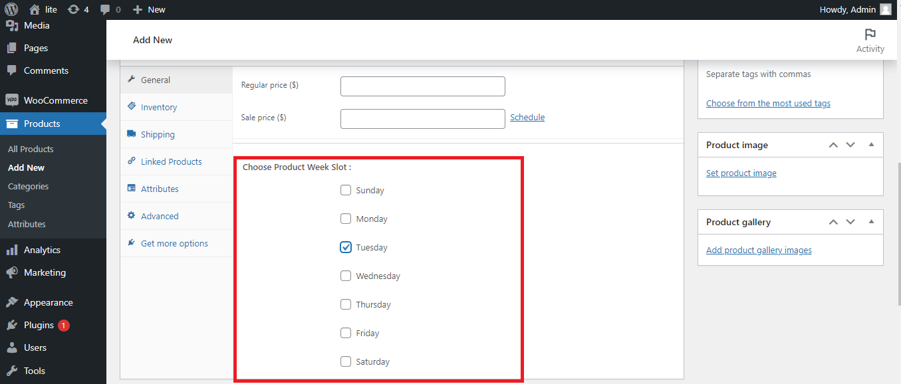

Note: Before moving to the next step, You have to make changes in the settings of the WordPress

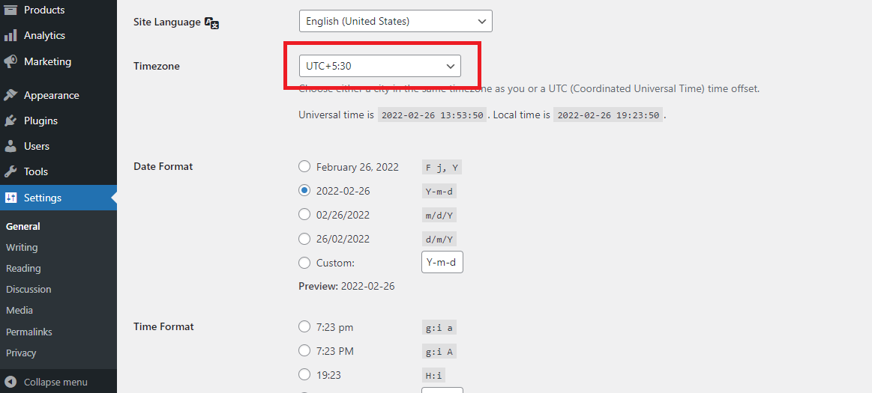

Go to Settings🡪General🡪Choose Timezone [According to Your Country]

Step 6: Now, You can add new products and apply validations to those products and you can also view your products on the shop page and check the restriction product visibility

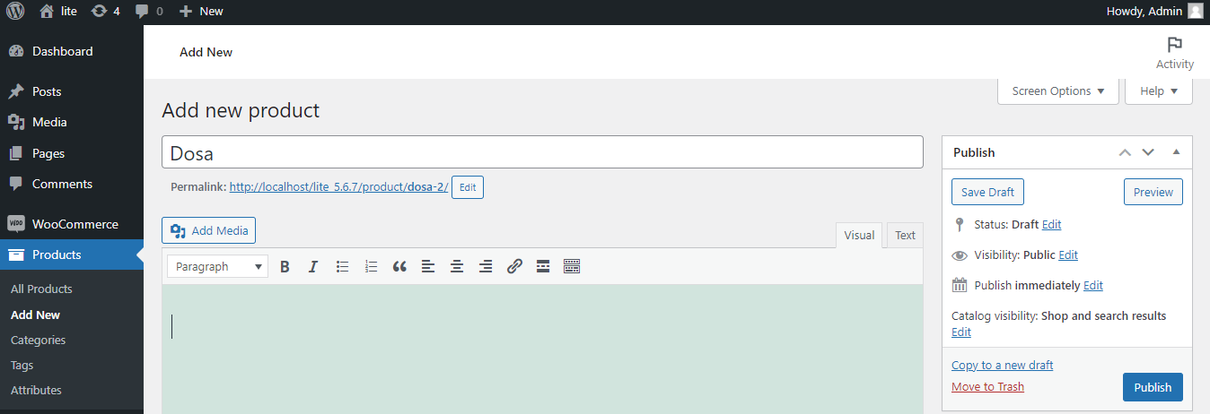

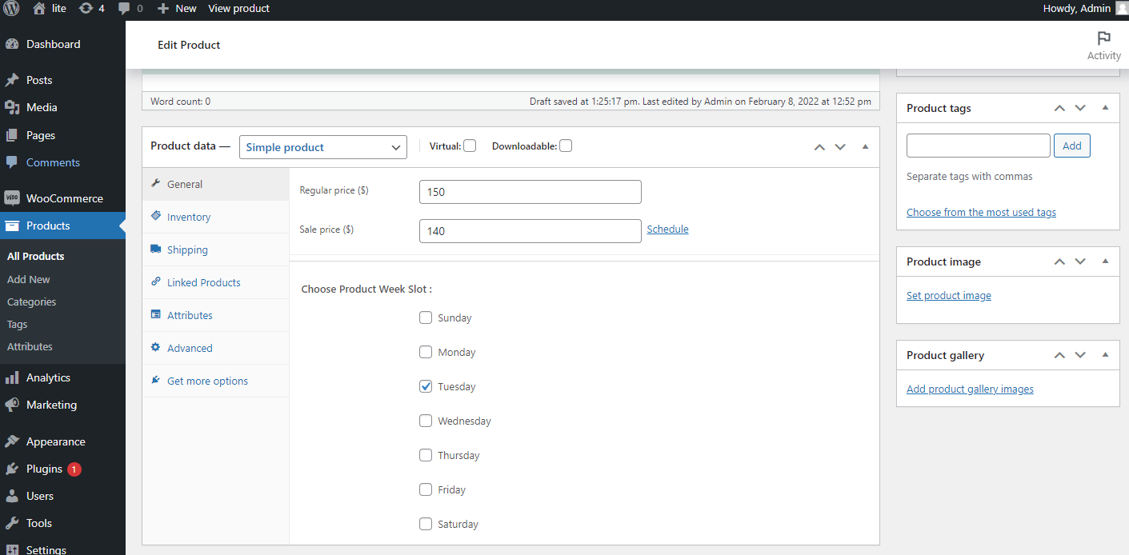

Note:- In this case, we are selecting the Tuesday slot to display the product, as you can see the product on the shop page because it automatically detects the day from your WordPress.



Note:- In this case, we are assigning a Wednesday slot to display the product

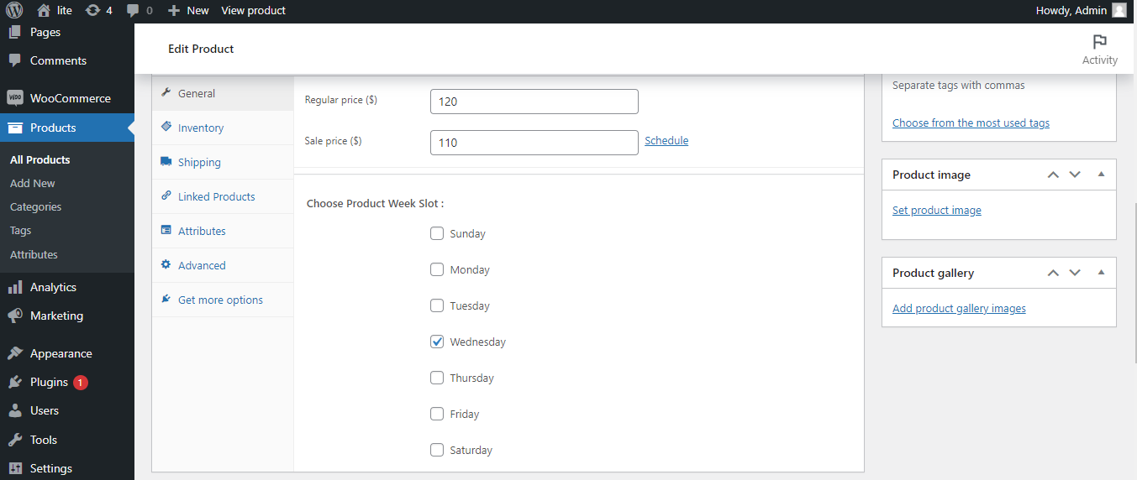

Result:- As you can see the shop page is empty because it detects the day i.e Tuesday. In this case, the product hides automatically and it will be visible on the allocated day.

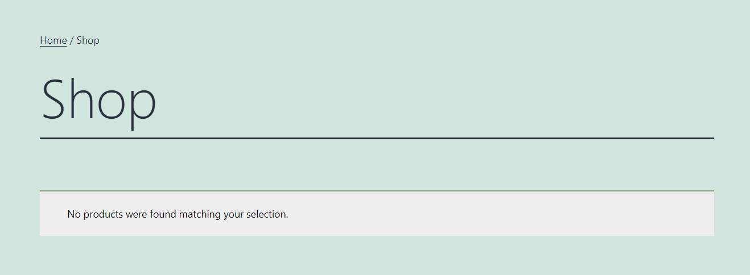

Step 7: If you want to delete the plugin, firstly you have to deactivate the plugin.

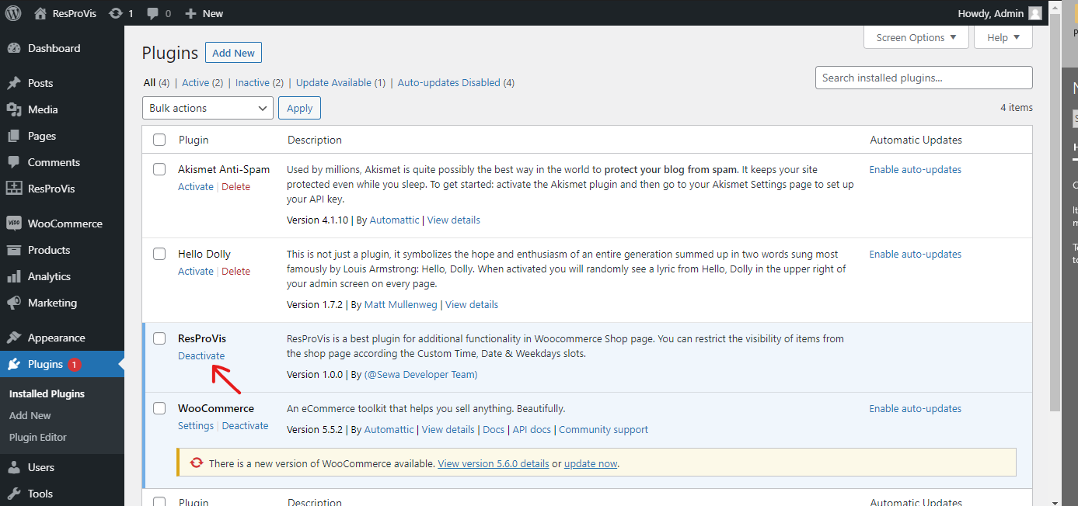

Step 8: To delete the plugin, Click on the delete

